
Press Contact:
Lisa Jaehnig | Shuman Associates
ljaehnig@shumanassociates.net | (212) 315-1300

For Immediate Release



MALEK JANDALI CONCERTOS TO BE RELEASED
BY CEDILLE RECORDS ON MAY 12

Violinist Rachel Barton Pine and clarinetist Anthony McGill are featured soloists on world premiere recordings of new concertos by Syrian American composer Malek Jandali, with Marin Alsop and the ORF Vienna Radio Symphony

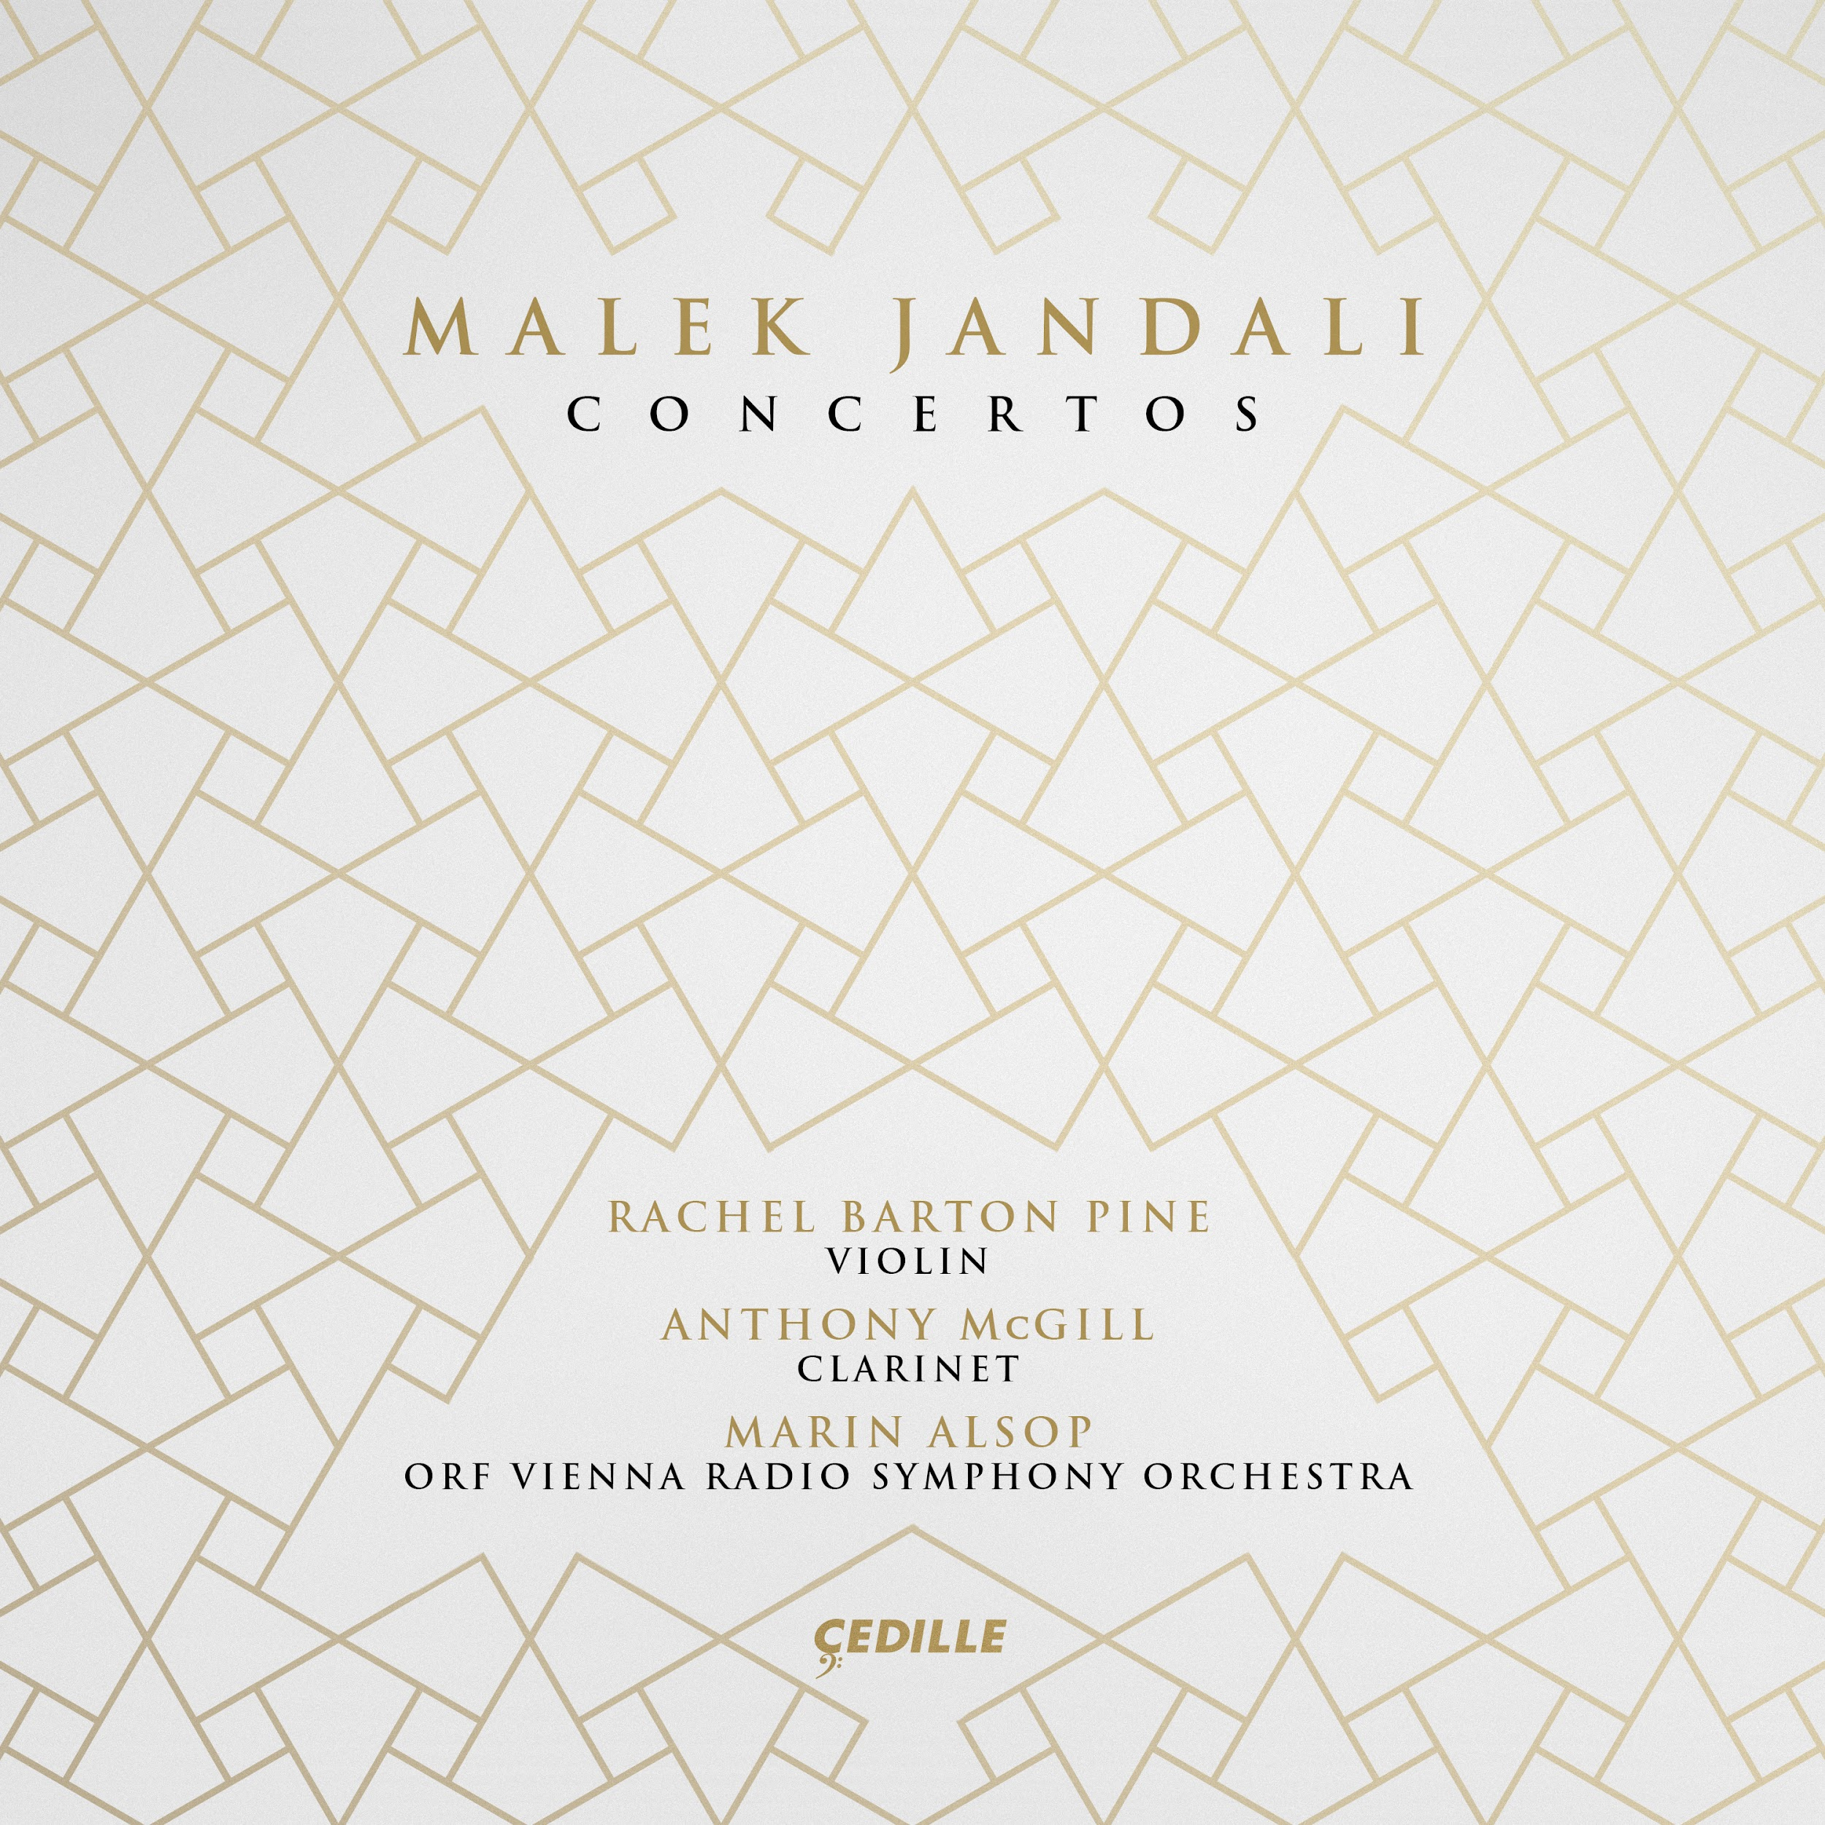

CHICAGO (April 17, 2023) — Cedille Records releases Malek Jandali Concertos, an album featuring violin and clarinet concertos by the Syrian American composer Malek Jandali, who has been praised for writing “heart-rending melodies, lush orchestration, clever transitions and creative textures'' (American Record Guide). The album, to be released on May 12, 2023, comprises world premiere recordings of Jandali’s Concerto for Violin and Orchestra with Rachel Barton Pine and Concerto for Clarinet and Orchestra with Anthony McGill, performed by the ORF Vienna Radio Symphony Orchestra led by Marin Alsop, a champion of the composer’s music.

Malek Jandali is dedicated not only to preserving Syria’s cultural heritage but also to humanitarian causes. His music is infused with ancient themes and Syrian melodies and idioms — an homage to the composer’s homeland as a means of preservation — and Western-inspired harmonies and forms.

Rachel Barton Pine, hailed as “an exciting, boundary-defying performer” by The Washington Post, is soloist on Jandali’s Concerto for Violin and Orchestra (2014), a work that calls upon an array of Syrian and Arabic music forms and folk melodies including multiple samā’i and bashraf (instrumental pieces), and longa (dances), from different maqam (modes). The concerto also makes use of the oud (Arabic lute) to infuse the work with the authentic sound and feeling of Syria. Says Rachel Barton Pine, “Just hearing that sound as I’m playing my music on this Western instrument in this Western symphony context was really very inspiring and helped me capture the flavor of what I was doing that much better.”

The violin concerto honors “all women who thrive with courage,” according to the composer, and it is dedicated to the women of Syria who have endured oppression and hardship, including Tal al-Mallohi, a student and blogger who was arrested in 2009 and spent 11 years in prison for expressing her thoughts; Razan Zaitoneh, the human rights lawyer who went into hiding after being accused of being a foreign agent during the Syrian Revolution and is now thought to have been killed; Rania al-Abbasi, a dentist and chess champion who was arrested in 2013 for unknown reasons and has not been heard from since; and Lina Droubi, Jandali’s mother, who with his father, Dr. Mamoun Jandali, was brutally beaten in Syria after Malek performed at a 2011 peaceful protest in front of the White House.

Jandali’s virtuosic Concerto for Clarinet and Orchestra (2021) similarly explores variations on themes from old and traditional Syrian musical forms and modalities including an ancient Syrian samā’i and a traditional Syrian wasla, with striking musical effects and wide ranging highs and lows in the orchestral writing. The work is dedicated to its performer Anthony McGill, the 2020 Avery Fisher Prize recipient, “in memory of all victims of injustice.” McGill, who the New York Times describes as “a captivating virtuoso on the stage and… a longtime advocate for social change extending beyond it,” says of the work, ”In the midst of the pain and the violence and injustice in the world all we are left with is the ability to pour our hearts and our souls into something more beautiful, into something more powerful, so it can communicate throughout all time and live on.”

Marin Alsop, who has conducted many of Malek Jandali’s works, also emphasizes the moral thread that permeates Jandali’s music. “Malek composes in some ways very traditionally because he uses notation and techniques that the instrumentalists are familiar with; but like Bartók did, like Dvořák did, he uses his cultural folk music as a real underpinning for developing these themes, developing these ideas. But the most important part of the story is always the moral… My job is to find the moral to the story and get that across, and Malek’s music is very, very strong in its intentionality and its desire to really stand up for those who don’t have a voice.”

The album’s executive producer is Malek Jandali; music producer is Erich Hofmann; session engineer is Friedrich Trondl; with mixing and mastering by Bill Maylone. Jandali’s Violin Concerto and Clarinet Concerto were recorded May 27–29, 2022 at the Funkhaus Wien Großer Sendesaal in Vienna, Austria. Malek Jandali Concertos was recorded with support from the Qatar Museums (QM), the nation’s preeminent institution for art and culture, which provides authentic and inspiring cultural experiences through a growing network of museums, heritage sites, festivals, public art installations, and programs. Malek Jandali is honorary composer-in-residence at QM in partnership with Years of Culture.

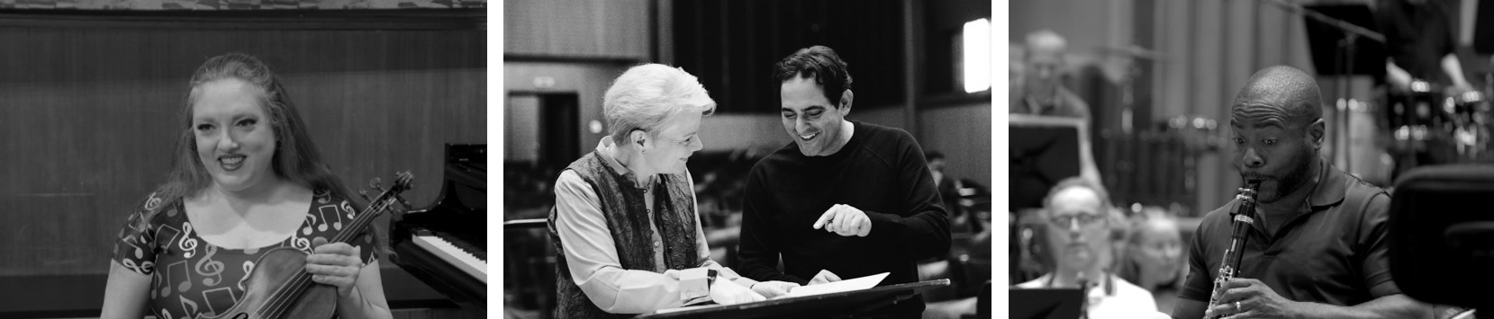

MALEK JANDALI
Malek Jandali’s music is widely regarded as “a major new addition to the 21st century’s symphonic literature” (Fanfare). Recent commissions and premieres include a viola concerto for Roberto Diaz, a string quartet for the Nashville Symphony, and a world premiere by the Baltimore Symphony Orchestra led by Marin Alsop. His music not only integrates Middle-Eastern modes into Western classical forms and harmony, but also echoes UNESCO’s call to preserve and protect the rich cultural heritage of his homeland Syria at a time when it is being eradicated. His repertoire ranges from chamber music to large-scale orchestral works including seven symphonies, eight concertos, and various programmatic pieces. Jandali’s works have been performed by numerous orchestras including the Royal Philharmonic, Baltimore Symphony, Zagreb Philharmonic, Cairo Symphony, Russian Philharmonic, and ORF Vienna Radio Symphony Orchestra. Jandali is composer-in-residence at Queens University, where he once studied with Paul Nitsch, a student of Leon Fleisher. He is also the founder and CEO of Pianos for Peace, a non-profit organization dedicated to building peace through music and education. Jandali has produced ten albums comprising more than 40 of his compositions.

RACHEL BARTON PINE
Heralded as a leading interpreter of the great classical masterworks, concert violinist Rachel Barton Pine thrills international audiences with her dazzling technique, lustrous tone, and emotional honesty. With an infectious joy in music-making and a passion for connecting historical research to performance, Pine transforms audiences’ experiences of classical music. Pine performs with the world’s leading orchestras including The Philadelphia Orchestra, Royal Philharmonic Orchestra, Camerata Salzburg, and the Chicago, Vienna, and Detroit Symphony Orchestras. She has worked with renowned conductors including Teddy Abrams, Marin Alsop, Daniel Barenboim, Semyon Bychkov, Neeme Järvi, Christoph Eschenbach, Erich Leinsdorf, Nicholas McGegan, Zubin Mehta, Tito Muñoz, and John Nelson. She has recorded over 40 acclaimed albums (more than 20 for Cedille Records), many of which have hit the top of the charts. Most recently, in 2022 Cedille Records released her Violin Concertos by Black Composers Through the Centuries: 25th Anniversary Edition, which features a new recording of Florence Price’s Violin Concerto No. 2 with the Royal Scottish National Orchestra and Jonathon Heyward. She has appeared on The Today Show, CBS Sunday Morning, CNN, PBS NewsHour, A Prairie Home Companion, and NPR’s Tiny Desk. Her RBP Foundation assists young artists through its Instrument Loan Program and Grants for Education and Career, and since 2001, has run the groundbreaking Music by Black Composers project. She performs on the “ex-Bazzini, ex-Soldat” Joseph Guarnerius “del Gesù” (Cremona 1742), on lifetime loan from her anonymous patron.

ANTHONY McGILL
Hailed for his “trademark brilliance, penetrating sound and rich character” (New York Times), clarinetist Anthony McGill enjoys a dynamic international music career and is principal clarinet of the New York Philharmonic — the first African-American principal player in the organization's history. He is the recipient of the 2020 Avery Fisher Prize, one of classical music’s most significant awards given in recognition of musicians who represent the highest level of musical excellence. McGill appears as a soloist with top orchestras, including the New York Philharmonic, Metropolitan Opera, and the Baltimore, Boston, Chicago, and Detroit Symphony Orchestras. He performed alongside Itzhak Perlman, Yo-Yo Ma, and Gabriela Montero at the first inauguration of President Barack Obama, premiering a piece by John Williams. He serves on the faculty of The Juilliard School and the Curtis Institute of Music, where he holds the William R. and Hyunah Yu Brody Distinguished Chair. He is the Artistic Director for Juilliard’s Music Advancement Program, a weekend program dedicated to students who demonstrate a commitment to artistic excellence, which actively seeks young musicians from backgrounds underrepresented in classical music. In 2020, McGill’s #TakeTwoKnees campaign protesting the death of George Floyd and historic racial injustice went viral. This is Anthony McGill’s sixth recording for Cedille Records.
MARIN ALSOP
One of the foremost conductors of our time, Marin Alsop represents a powerful and inspiring voice. The first woman to serve as the head of a major orchestra in the U.S., South America, Austria, and Britain, she is Chief Conductor of Vienna’s ORF Vienna Radio Symphony Orchestra and Chief Conductor and Curator of Chicago’s Ravinia Festival, where she curates and conducts the Chicago Symphony’s summer residencies. She holds the title of Music Director Laureate and OrchKids Founder of the Baltimore Symphony, after an outstanding 14 years as its Music Director. Also serving as Conductor of Honour of Brazil’s São Paulo Symphony, the first Music Director of the University of Maryland’s National Orchestral Institute + Festival, and 2021–2022 Harman/Eisner Artist-in-Residence of the Aspen Institute Arts Program, she was Music Director of California’s Cabrillo Festival of Contemporary Music for 25 years. The first and only conductor to receive a MacArthur Fellowship, she has also received the World Economic Forum’s Crystal Award and numerous honorary doctorates. To promote and nurture the careers of her fellow female conductors, she founded the program now named the Taki Alsop Conducting Fellowship. The Conductor, an award-winning documentary about her life, debuted at New York’s 2021 Tribeca Film Festival.

ORF VIENNA RADIO SYMPHONY ORCHESTRA
The ORF Vienna Radio Symphony Orchestra (Vienna RSO) is known for its exceptional, bold programming, often placing Romantic era classics in unexpected contexts, combining 19th-century repertoire with contemporary pieces and rarely performed works of other periods. The Vienna RSO regularly performs in Vienna’s Musikverein and the Konzerthaus, appears annually at major Austrian and international festivals, and frequently tours to European countries and overseas. Since 2007, the Vienna RSO has also collaborated as an opera orchestra with the MusikTheater an der Wien. Many Vienna RSO performances are broadcast on the Österreich 1 station, as well as internationally. The broad scope of the Vienna RSO’s recording activities includes works in every genre, among them many first recordings that represent modern Austrian classicists and contemporary Austrian composers. Five Vienna RSO recordings have received Opus Klassik awards; and in 2018 the Vienna RSO won a prestigious International Classical Music Award in the Symphonic Music category for its set of recordings, Martinů: The Symphonies.

CEDILLE RECORDS
Launched in November 1989 by James Ginsburg, Grammy Award-winning Cedille Records (pronounced say-DEE) is dedicated to showcasing and promoting the most noteworthy classical artists in and from the Chicago area. The label’s catalog of more than 200 front-line albums brims with attractive, off-the-beaten-path repertoire from the Baroque era to the present day. Works from the classical canon, when they do appear, are usually heard in particularly imaginative pairings. Cedille has recorded more than 180 Chicago artists and ensembles, with over 80 making their professional recording debuts on the label. Its catalog includes the world premieres of more than 400 classical compositions. Cedille recordings are available on CD, as MP3 and hi-resolution FLAC downloads, and on all major streaming platforms.

MALEK JANDALI CONCERTOS
(CDR 90000 220)
Rachel Barton Pine, violin
Anthony McGill, clarinet
Marin Alsop, Conductor
ORF Vienna Radio Symphony Orchestra

MALEK JANDALI (b. 1972)
Concerto for Violin and Orchestra (35:52)
1 I. Allegro moderato (17:31)
2 II. Andante (9:42)
3 III. Allegretto (8:28)

Concerto for Clarinet and Orchestra (25:00)
4 I. Andante misterioso—Più mosso (7:38)
5 II. Nocturne: Andante (8:11)
6 III. Allegro moderato (9:01)

ALL WORLD PREMIERE RECORDINGS
TT: (61:04)
###

